Project 1
Interpret Data Visualizations – Using the Madrid in detail – ‘From Madrid to Heaven’ dashboard.

Insight 1 – Districts with most Population Density and most population by hectare

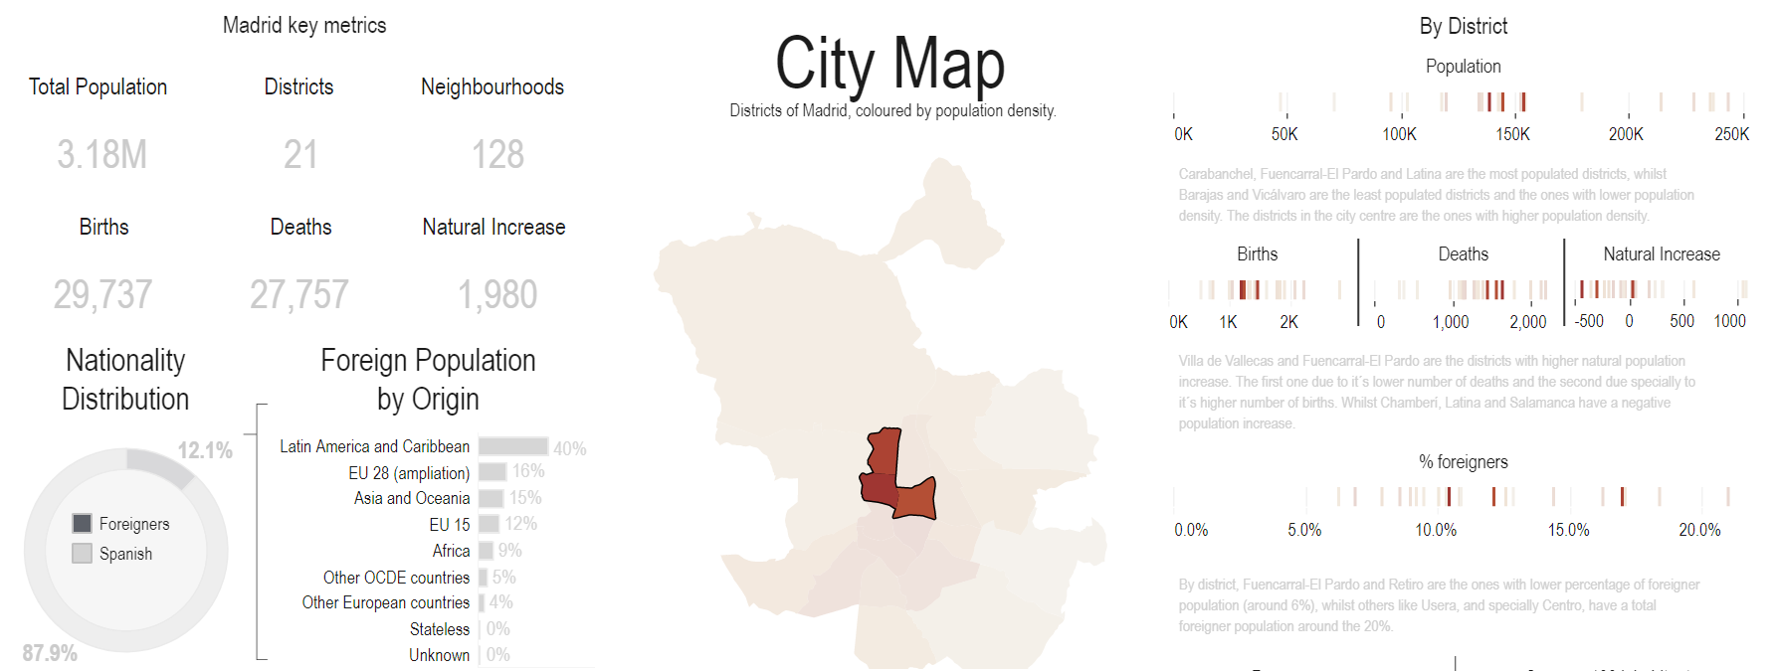
In this part, I moused over the City Map and changed, using the dropdown menu, to “District”. Using this heatmap, I could easily find that the three districts with the most Population Density by hectare were “Chamberí”, “Tetuán” and “Salamanca”, respectively.
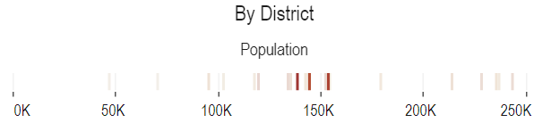
Then, I’ve moused over the graph above, and saw that the same three districts had the hectares of 138.201, 153.450 and 144.049, respectively.
Despite that, these three were not the most populated, those were “Carabanchel”, “Fuencarral-El Pardo” and “Latina”, which can be seen in the graph above, and is in agreement with the statement on the chart.
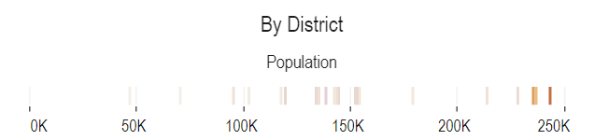
By clicking one of those districts, we can see that the heatmap isolates the specific district, which helps us to isolate it in the map and the other charts as well.
Insight 2 – Correlation between second hand housing prices per m2 and party orientation

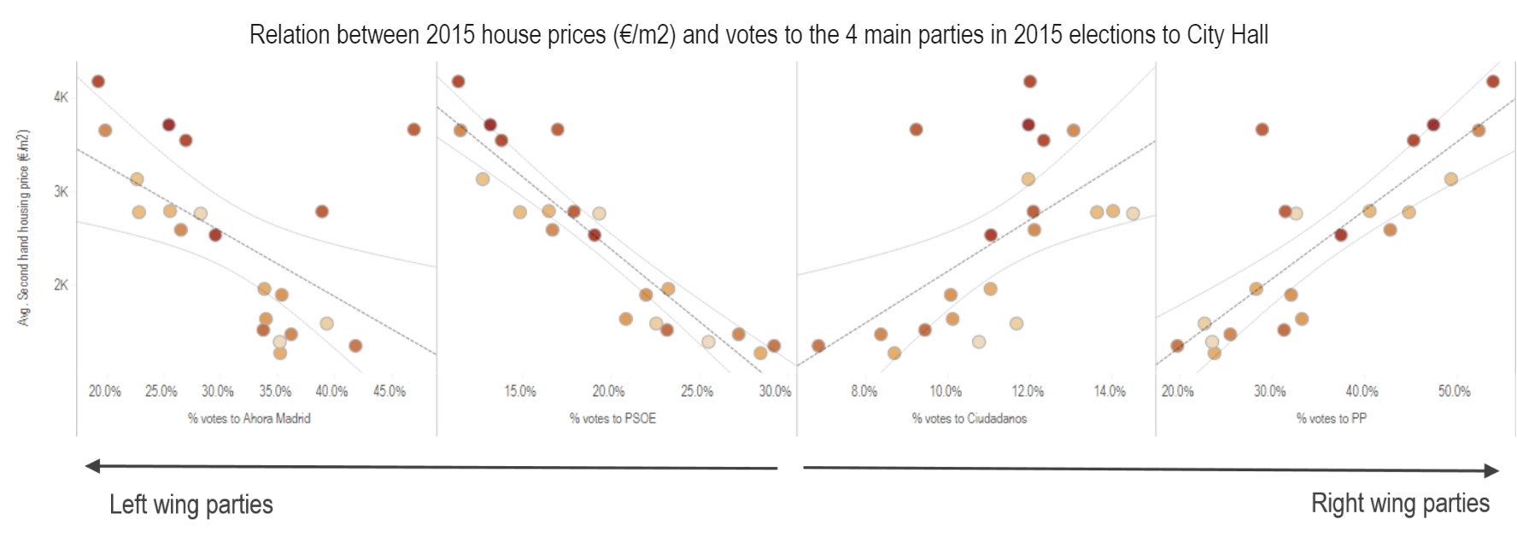
In this graph, we can clearly and easily find that right wing party votes in 2015 elections to City Hall were highly correlated with bigger avg. second hand housing prices per m2, while the opposite is true for left wing parties, it Is inversely correlated, as the lower housing prices, the higher votes.

Insight 3 – Correlation between second hand housing prices per m2 and party orientation

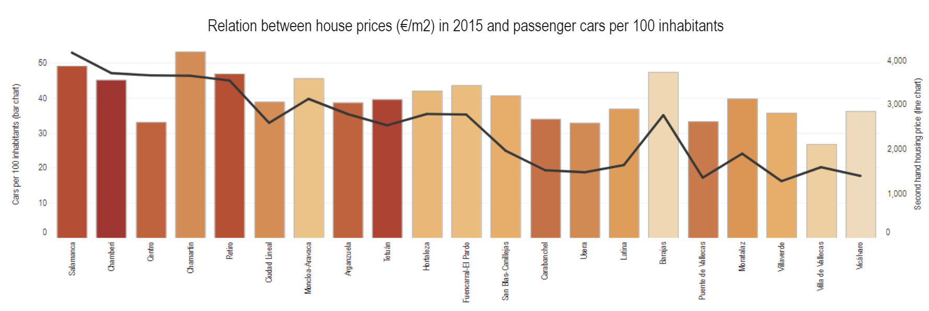
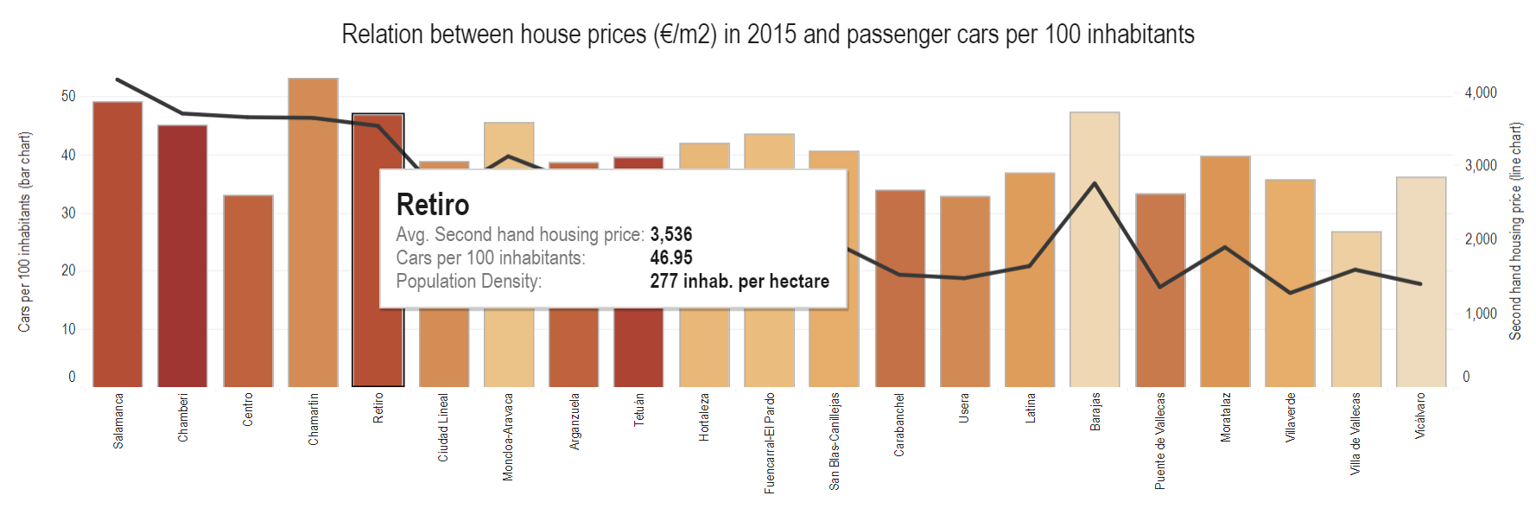
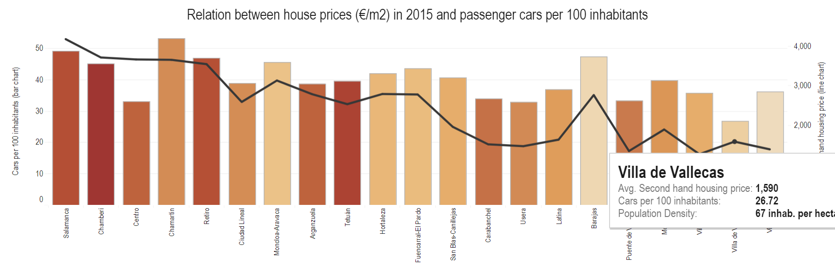
Contrary to what I would intuitively believe, the higher the house prices, it seems that the higher the car counts per 100 habitants are.
This can be easily observed in the graphs above.

